BECA / Huson / 12.1. IB Math SL

October 24, 2017

**Calculus limit question - Markscheme**

**1a.** Let  . *[2 marks]*

Expand  .

## Markscheme

attempt to expand ***(M1)***

 ***A1 N2*** ***[2 marks]***

## Examiners report

In part (a), the basic expansion was not done well. Rather than use the binomial theorem, many candidates opted to expand by multiplication which resulted in algebraic errors.

**1b.** *[4 marks]*

Use the formula 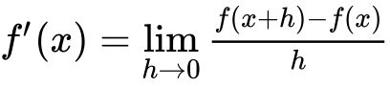 to show that the derivative of  is  .

## Markscheme

evidence of substituting  ***(M1)***

correct substitution ***A1***

e.g. 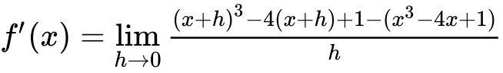

simplifying ***A1***

e.g. 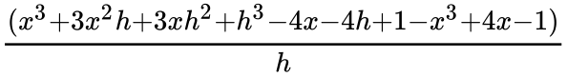

factoring out *h* ***A1***

e.g. 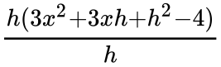

 ***AG N0***  ***[4 marks]***

## Examiners report

In part (b), it was clear that many candidates had difficulty with differentiation from first principles. Those that successfully set the answer up, often got lost in the simplification.

**1c.** The tangent to the curve of f at the point  is parallel to the tangent at a point Q. Find the coordinates of Q. *[4 marks]*

## Markscheme

 ***(A1)***

setting up an appropriate equation ***M1***

e.g. 

at Q,  (Q is ) ***A1 A1*** ***[4 marks]***

## Examiners report

Part (c) was poorly done with many candidates assuming that the tangents were horizontal and then incorrectly estimating the maximum of *f* as the required point. Many candidates unnecessarily found the equation of the tangent and could not make any further progress.

**1d.** *[3 marks]*

The graph of *f* is decreasing for  . Find the value of *p* and of *q*.

## Markscheme

recognizing that *f* is decreasing when  ***R1***

correct values for *p* and *q* (but do not accept  ) ***A1A1 N1N1***

e.g.  ; 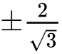 ; an interval such as  ***[3 marks]***

## Examiners report

In part (d) many correct solutions were seen but only a very few earned the reasoning mark.

**1e.** Write down the range of values for the gradient of  . *[2 marks]*

## Markscheme

 ,  ,  ***A2 N2*** ***[2 marks]***

## Examiners report

Part (e) was often not attempted and if it was, candidates were not clear on what was expected.